[INSERT SCHOOL] Digital Safety Management - Template

Name of platform, app or digital device

Proposed users
Age restrictions (T&Cs)
Reason for use and intended purpose
Suggested admins (min. 2)
Duration of use
Sign off
(at conclusion of the DSMP process)

Additional Details | Considerations | Steps to minimise potential risks
Is individual sign-up and consent required? | Check terms and conditions of platform/app and school policies
What are our terms & conditions for use? | Minimum age restrictions  Implications for the school/students  How these align with school’s policies and values
How will we mitigate any privacy risks? | Use of student images and information  Who can access information and images  Alignment with school’s policies and values | Risk:  Mitigation of risk:  Risk:  Mitigation of risk
Are there other identified risks/challenges? How will these be mitigated? |  | Risk:  Mitigation of risk:  Risk:  Mitigation of risk:
How will we moderate content and participation? | Who comments/participates  Who can view or access content  Who oversees and moderates content
How will we communicate with parents and whānau? | Transparency around purpose: who uses it, when will it be used, how will it be used, expectations of use, duration of use, risk mitigation
What are the rights and responsibilities of users? | Expectations of use and user agreement? Option to opt out?
How will we manage incidents, complaints and concerns | What procedures and processes are in place to support students?  How will we share this process with students and their families?

Are there other similar platforms, apps or devices available?

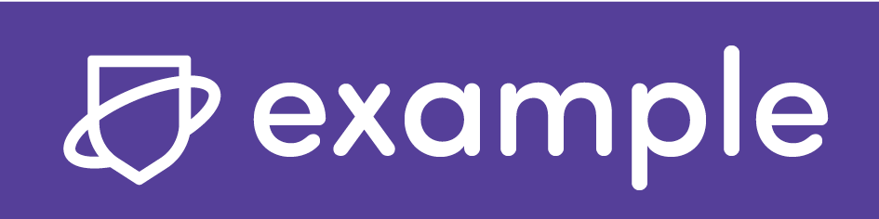

[EXAMPLE SCHOOL] Digital Safety Management - Example

Name of platform, app or digital device | Houseparty - social media network (owned by Epic Games)
Proposed users | Y5-6 students
Age restrictions (T&Cs) | 13 years+ but no age verification required
Reason for use and intended purpose | A good way for students to connect with one another via video chat. Popular with students so likely to have good buy-in. They are already familiar with how it works and have pre-existing accounts.
Suggested admins (min. 2) | Class teachers
Duration of use | For period of lockdown remote learning
Sign off  (at conclusion of the DSMP process) | Sign off/consent complete:  Consent for use within school remote learning environment not given.  Risks outweigh benefits and other alternative platforms provider greater safety for students and staff

Additional Details | Considerations | Steps to minimise potential risks
Is individual sign-up and consent required? | Check terms and conditions of platform/app and school policies | - Each user needs to sign up and create their own account.  13 minimum age limit
What are our terms & conditions for use? | Minimum age restrictions  Implications for the school/students  How these align with school’s policies and values | - Users need to be 13+ but no age verification in place  Data is collected automatically but you can opt out of sharing some nonpersonal information – possible conflicts with school privacy expectations
How will we mitigate any privacy risks? | Use of student images and information  Who can access information and images  Alignment with school’s policies and values | Risk: Screens can be recorded by others and possibly shared.  Mitigation of risk: Lock rooms but this does not prevent someone in the room recording the screens.  Risk: Data is automatically collected and data considered ‘non-personal’ is retained.  Mitigation of risk: Limit personal information shared.  Risk: Relies on access to contacts stored on the device.  Mitigation of risk: Unknown.  Refer to areas of the School Privacy Policy that address use of student images/content in learning environments.
Are there other identified risks/ challenges? How will these be mitigated? |  | Risk: People can join without information or warning. Don’t need an invitation to join.  Mitigation of risk: Lock rooms.  Risk: Asks for location so users can connect with other users or people nearby  Mitigation of risk: Change location privacy settings  Risk: Accounts could be hacked  Mitigation of risk: Encourage students to use strong passwords

Additional Details |  | Considerations |  | Steps to minimise potential risks
 | How will we moderate content and participation? |  | Who comments/participates  Who can view or access content  Who oversees and moderates content |  | Students will be able to comment, participate and access all content shared once they are in the room. Class teacher will moderate content. All students to understand behavioural and participation expectations prior to using the platform.
 | How will we communicate with parents and whānau? |  | Transparency around purpose: who uses it, when will it be used, how will it be used, expectations of use, duration of use, risk mitigation |  | Teacher will share information about the platform with parents via email and class blog.  Parents will be asked to approve usage and to monitor usage at home.  Platform to only be used by the class for “connection” time at the start of the day, any teacher-led instruction and for the end of the day class “catch up”. Students will not be able to use  it at other times.  Students will co-construct a participation agreement which will outline acceptable behaviours and what they can do if things go wrong.
 | What are the rights and responsibilities of users? |  | Expectations of use and user agreement? Option to opt out? |  | Students will co-construct a use agreement and parents will see it, so they know what has been agreed to. They will know what to do if things go wrong and what actions might be for inappropriate behaviour or use of the platform.  No alternative options if parents and students choose not to use the platform.
 | How will we manage incidents, complaints and concerns |  | What procedures and processes are in place to support students?  How will we share this process with students and their families? |  | Will co-construct an agreement with students and this will include the action that might be taken if expectations are not met. Parents will also be a part of this. All students will know that the teacher is their first contact if things happen that impact them.  All incidents will be recorded on class incident sheet and will be dealt with according to school processes.
 | Are there other similar platforms, apps or devices available? |  |  |  | Other options include Google Meet (as part of G-Suite) and Zoom.

