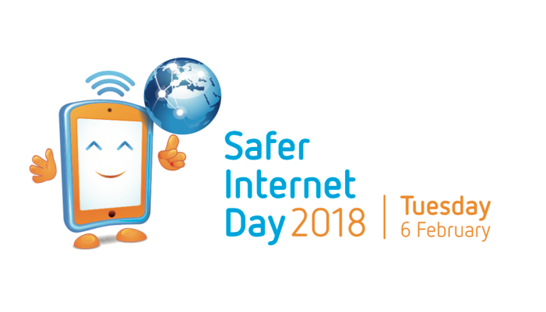

Safer Internet Day 2018 Story

Safer Internet Day is here
Safer Internet Day is celebrated globally each year on 6 February and promotes the safe and positive use of digital technology. Coordinated in New Zealand by Netsafe, Safer Internet Day is an opportunity for everyone to learn about the things we can do to stay safe online.

Why should you care about Safer Internet Day?
Eight out of ten people in New Zealand use a smartphone regularly, and more than half of all New Zealanders spend more than two hours online each day. The internet is a great tool that has changed the way we interact with the world. It’s changed the way we share ideas, buy and sell, learn new things and meet new people. We’re more connected than ever. This brings opportunities – and some challenges.

Why and how to get involved
Did you know that one third of New Zealanders have received an unwanted communication online in the last year? Online challenges affect everybody and having the knowledge to make the right decisions is the first step to creating a better internet.
For Safer Internet Day 2018 Netsafe has created a Staying Safe Online Guide to make staying safe online easier for everybody. The guide is full of helpful advice, tips and how-to guides from some of the biggest names in tech like Google, Facebook, Youtube, Twitter, and Trade Me.

Read through the advice and make sure you share it with your friends, family and whānau on social media or by printing it out.
You can find the full guide here and read advice some advice from the guide below:
Get scam ready
- Be careful with unexpected contact – e.g about a competition you didn't enter.
- Be wary if someone tries to move a deal outside of a trusted trading platform.
- Never give your password to anyone, even trusted organisations.
Shop safer online
- Use trusted WiFi connections or mobile data when making an online purchase or logging into accounts.
- Use a credit card or trusted payment service to ensure better protection if something goes wrong.
Double up your security
- Two-Factor Authentication (2FA) is an extra layer of security for your online account. It's an extra step on top of your password that makes it harder for others to access your account. Use 2FA on every account you can.
Power up your passwords
- Make your password at least 15 characters’ long
- Use a unique phrase instead of a word
- Use a different password for each account
- Don’t use personal info that could easily be guessed
- Change your passwords regularly · More at netsafe.org.nz/passwords
Find the full staying safe online guide netsafe.org.nz/staying-safe-online

About Netsafe
Netsafe is a not-for-profit organisation that focuses on online safety. They offer support, advice and education to everyone in New Zealand to help minimise online risks. Whether you’re dealing with online bullying, an online request that looks suspicious, or you just want advice for family members using the internet they can help.
Follow Netsafe on Facebook and Twitter to keep up to date with Safer Internet Day 2018 and the latest in online safety news, advice, tips and information.

Safer Internet Day 2018 Blurb
6 February is Safer Internet Day. Did you know that one third of adults in New Zealand have experienced an unwanted online communication in the last year? Netsafe has published a guide full of advice to help you and your family stay safe online. It’s full of tips from Google, Facebook, Trade Me and more. Find the guide at netsafe.org.nz/staying-safe-online
